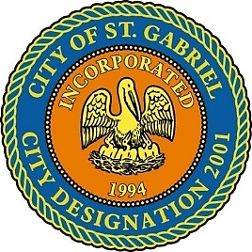

SPECIAL MEETING OF THE MAYOR AND CITY COUNCIL

TUESDAY, APRIL 28, 2020 - 6:00 P.M.

This meeting will be available for viewing on www.cityofstgabriel.us, on Metro 21 (Cox Channel 21), and on the City of St. Gabriel Facebook page (via Facebook Live).

CERTIFICATION OF INABILITY TO OPERATE DUE TO LACK OF QUORUM

I, LIONEL JOHNSON, JR., on behalf of and as Mayor for the City of St. Gabriel, Louisiana, organized and existing under the laws of the State of Louisiana, do hereby certify that pursuant to Proclamation JBE 2020-30 and the March 19, 2020 Louisiana Attorney General Memorandum that the St. Gabriel City Council would otherwise be unable to meet quorum requirements as a result of the COVD-19 public health emergency and will therefore conduct a Special City Council Meeting April 28, 2020 beginning at 6:00 o’clock p.m. via teleconference and/or video conference.

**AGENDA**

**I. CALL TO ORDER – ROLL CALL – PRAYER – PLEDGE OF ALLEGIANCE**

1. **MOTION TO APPROVE** – Minutes for Regular Meeting dated February 20, 2020
2. **MOTION CONSIDERATION** – To ratify the Mayor’s authority to execute said items under Declaration of Public Health Emergency – COVID-19:
   1. Pay app#4 in the amount of $310,005.89 for Wharton-Smith, Inc. for Sunshine Wastewater Treatment Facility
   2. Pay app#5 in the amount of $152,950.00 for Wharton-Smith, Inc. for Sunshine Wastewater Treatment Facility
   3. Act Establishing Boundary and Quit Claim for Gary and Wanda Miles
   4. Act Establishing Boundary and Quit Claim for Adrian and Valerie Wilson
   5. Approve Final Plat of Oak Trace Subdivision
3. **MAYOR REPORT**
   1. Request for approval of substantial completion for Phase 5 Road Project
   2. Official Condolences
   3. COVID-19
   4. Insurance Renewal
4. **COUNCIL REPORT**
5. **ADJOURNMENT**