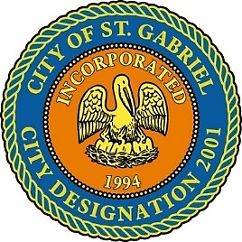

REGULAR MEETING OF THE MAYOR AND CITY COUNCIL

TUESDAY, NOVEMBER 19, 2019 - 6:00 P.M.

ST. GABRIEL CITY HALL COMPLEX - 5035 IBERVILLE STREET - ROOM 32

ST. GABRIEL, LOUISIANA

**AGENDA**

**I. CALL TO ORDER – ROLL CALL – PRAYER – PLEDGE OF ALLEGIANCE**

1. **PUBLIC FORUM** – **3-minute limit (Please register with the City Clerk prior to the beginning of the meeting indicating your topic of discussion.) Topics should be on agenda items and/or city government concerns.**
2. **MOTION TO APPROVE** – Minutes for Regular Meeting dated October 17, 2019
3. **INTRODUCTION** - LBC, Rail Logix
4. **INTRODUCTION** - Air products proposal for participation in the Industrial Tax Exemption Program (ITEP)
5. **MAYOR REPORT**
6. **COUNCIL REPORT**
7. **ADJOURNMENT**