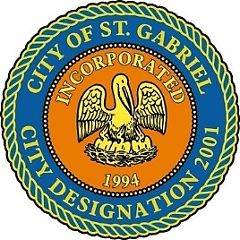

SPECIAL MEETING OF THE MAYOR AND CITY COUNCIL

TUESDAY, AUGUST 27, 2019 - 6:00 P.M.

ST. GABRIEL CITY HALL COMPLEX - 5035 IBERVILLE STREET - ROOM 32

ST. GABRIEL, LOUISIANA

**AGENDA**

**I. CALL TO ORDER – ROLL CALL – PRAYER – PLEDGE OF ALLEGIANCE**

1. **PUBLIC FORUM** – Please register with the City Clerk prior to the beginning of the meeting indicating your topic of discussion. Topics should be on agenda items and/or city government concerns.
2. **MOTION CONSIDERATION** – To approve resolution of support for Ohmstede Industrial Services participation in the Industrial Tax Exemption Program (ITEP)
3. **ADJOURNMENT**

IF YOU NEED ADDITIONAL INFORMATION OR REQUIRE SPECIAL NEEDS TO ATTEND THIS MEETING, PLEASE NOTIFY THE CITY CLERK OR THE DEPUTY CLERK AT (225) 642-9600 AT LEAST 24-HOURS PRIOR TO THE MEETING. EVERY EFFORT WILL BE MADE TO ACCOMMODATE THE REQUEST, WITHIN REASON AND IN

ACCORDANCE WITH ADA GUIDELINES AND LAW