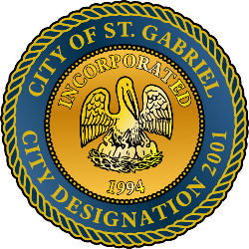

**CITY OF ST. GABRIEL, LA**

Regular MEETING OF THE MAYOR AND CITY COUNCIL

Thursday, MAY 16, 2019 - 6:00 P.M.

ST. GABRIEL CITY HALL COMPLEX - 5035 IBERVILLE STREET - ROOM 32

ST. GABRIEL, LOUISIANA

**AGENDA**

1. **CALL TO ORDER – ROLL CALL – PRAYER – PLEDGE OF ALLEGIANCE**
2. **PUBLIC FORUM** – 3 minute limit (Please register with the City Clerk prior to the beginning of the meeting indicating your topic of discussion.) Topics should be on agenda items and/or city government concerns.
3. **MOTION TO APPROVE** – Minutes for Regular Meeting dated April 18, 2019
4. **MAYOR REPORT**
5. **ADJOURNMENT**