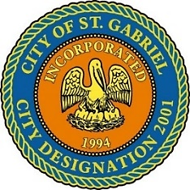

REGULAR MEETING OF THE MAYOR AND CITY COUNCIL

THURSDAY, AUGUST 19, 2021 - 6:00 P.M.

ST. GABRIEL CITY HALL COMPLEX - 5035 IBERVILLE STREET - ROOM 32

ST. GABRIEL, LOUISIANA

**AGENDA**

**I. CALL TO ORDER – ROLL CALL – PRAYER – PLEDGE OF ALLEGIANCE**

1. **PUBLIC FORUM** – **Please register with the City Clerk prior to the beginning of the meeting indicating your topic of discussion. Topics should be on agenda items.**
2. **MOTION** **CONSIDERATION** - To approve and adopt minutes for Regular Meeting dated July 15, 2021
3. **MOTION TO APPROVE** - Resolution of Condolence
   * 1. Family of Honorable Edwin Edwards – former Louisiana State Governor
     2. Family of Mr. Houston Thomas, Sr. – native and resident of St. Gabriel; father-in-law of Councilman Melvin Hasten, Sr.
     3. Family of Ms. Azure Pierson – resident of St. Gabriel; wife of Mr. George Pierson
     4. Family of Mr. Eddie Hargrove – resident of St. Gabriel
     5. Family of Ms. Prumiller Jones – native of Carville
     6. Family of Mr. Edward Ruffin – native and resident of St. Gabriel; uncle of former Councilman Freddie Frazier, Sr.
4. **NOTIFICATION –P**roposed RailPort facility located by LA 75, Carville, LA 70721.

**Current Zoning**: M2 Heavy Industrial

**Pending Approvals**: Drainage, Site Plan, Traffic Studies

1. **INTRODUCTION –** City Policy Manual and Employee Handbook
2. **COUNCIL REPORT**
3. **MAYOR REPORT**
4. **ADJOURNMENT**