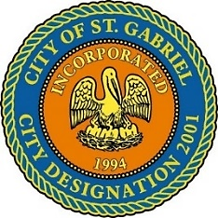

REGULAR MEETING OF THE MAYOR AND CITY COUNCIL
THURSDAY, OCTOBER 21, 2021 - 6:00 P.M.

ST. GABRIEL CITY HALL COMPLEX - 5035 IBERVILLE STREET - ROOM 32

ST. GABRIEL, LOUISIANA

AGENDA

I. CALL TO ORDER – ROLL CALL – PRAYER – PLEDGE OF ALLEGIANCE

- PUBLIC FORUM – Please register with the City Clerk prior to the beginning of the meeting indicating your topic of discussion. Topics should be on agenda items.
- MOTION CONSIDERATION
    - To approve and adopt minutes for Regular Meeting dated September 16, 2021
    - To approve and adopt minutes for Special Meeting dated September 28, 2021
- MOTION TO APPROVE - Resolution of Condolence
    - Family of Mr. Alvin Allen – Carville native; uncle of Councilman Ralph Johnson, Sr.
    - Family of Mr. Edward Grayer – St. Gabriel native
    - Family of Mrs. Helen M. Hollins – St. Gabriel native and resident; oldest known resident of St. Gabriel, LA (102 years old, 11/3/1918 – 9/30/2021)
    - Family of Mr. Eric Robinson - Carville native
    - Family of Ms. Ja’Laycia K. Mills - Sunshine native and resident; daughter of Planning and Zoning Chair, Ms. Kenya Nelson

- MOTION TO APPROVE - Resolution establishing 2021 trick or treat hours for the City of St. Gabriel for 6:00 p.m. to 8:00 p.m. for Sunday, October 31, 2021.
- COUNCIL REPORT
- MAYOR REPORT
- ADJOURNMENT

