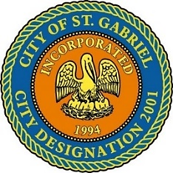

REGULAR MEETING OF THE MAYOR AND CITY COUNCIL
THURSDAY, NOVEMBER 18, 2021 - 6:00 P.M.

ST. GABRIEL CITY HALL COMPLEX - 5035 IBERVILLE STREET - ROOM 32

ST. GABRIEL, LOUISIANA

AGENDA

I. CALL TO ORDER – ROLL CALL – PRAYER – PLEDGE OF ALLEGIANCE

- PUBLIC FORUM – Please register with the City Clerk prior to the beginning of the meeting indicating your topic of discussion. Topics should be on agenda items.
- MOTION CONSIDERATION
    - To approve and adopt minutes for Regular Meeting dated October 21, 2021
- MOTION TO APPROVE - Resolution of Condolence
    - Family of Ms. Debra Diggs – St. Gabriel resident
    - Family of Mr. Willie Lee Arthur, Jr. – St. Gabriel native and resident; Brother-in-Law of Mrs. Debra Ausbon, Deputy City Clerk
    - Family of Ms. Mary Jackson – St. Gabriel native

- MOTION TO APPROVE – A Resolution of Recognition for St. Gabriel Tigers Youth Football Team
- MOTION CONSIDERATION – Ratify employment of police personnel
    - Johnny Williams Hire Date: 8/6/21
- COUNCIL REPORT
- MAYOR REPORT
- ADJOURNMENT

