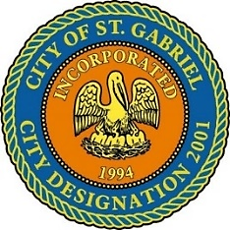

REGULAR MEETING OF THE MAYOR AND CITY COUNCIL
THURSDAY, DECEMBER 16, 2021 - 6:00 P.M.

ST. GABRIEL CITY HALL COMPLEX - 5035 IBERVILLE STREET - ROOM 32

ST. GABRIEL, LOUISIANA

AGENDA

I. CALL TO ORDER – ROLL CALL – PRAYER – PLEDGE OF ALLEGIANCE

- PUBLIC FORUM – Please register with the City Clerk prior to the beginning of the meeting indicating your topic of discussion. Topics should be on agenda items.
- MOTION CONSIDERATION
    - To approve and adopt minutes for Regular Meeting dated November 18, 2021
- MOTION CONSIDERATION – To Approve Resolution(s) of Condolence
    - Family of Mr. Louis John Ambeau - St. Gabriel, LA native and resident
    - Family of Mr. Michael Wilks Reames - St. Gabriel, LA native and resident

- MOTION TO ADOPT – Proposed design for the City’s Official Juneteenth flag
- INTRODUCTION - A resolution authorizing the establishment of single member districts for the 2023 City of St. Gabriel Council member elections and other matters related thereto
- MOTION CONSIDERATION – To hold a public hearing on Thursday, January 20, 2022 on the establishment of single member districts for the 2023 City of St. Gabriel Council member elections and other matters related thereto
- MOTION CONSIDERATION - To Approve a Resolution of Appreciation for City Attorney L. Phillip “Phil” Canova, Jr. on his retirement as City Attorney.
- MOTION CONSIDERATION – Personnel Recommendations
    - Mr. Dallon Bush – City Attorney

- COUNCIL REPORT
- MAYOR REPORT
- ADJOURNMENT

