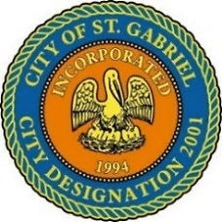

REGULAR MEETING OF THE MAYOR AND CITY COUNCIL
THURSDAY, JULY 21, 2022 - 6:00 P.M.

ST. GABRIEL CITY HALL COMPLEX - 5035 IBERVILLE STREET - ROOM 32

ST. GABRIEL, LOUISIANA

AGENDA

I. CALL TO ORDER – ROLL CALL – PRAYER – PLEDGE OF ALLEGIANCE

- PUBLIC FORUM – Please register with the City Clerk prior to the beginning of the meeting indicating your topic of discussion. Topics should be on agenda items.
- ACTION ITEMS
    - MOTION CONSIDERATION - To Approve and Adopt Minutes of Regular Meeting dated June 16, 2022 and Special Meeting dated June 21, 2022

- NON-ACTION ITEMS
  - RESOLUTION OF SUPPORT
      - PCS Nitrogen Fertilizer, LP Board of Commerce and Industry Approval Notice - Tax Exemption Application #20220104

      - Plug Power, Inc Board of Commerce and Industry Approval Notice -Tax Exemption Application #20220171
  - REPORT – Planning and Zoning

- COUNCIL REPORT
- MAYOR REPORT
- ADJOURNMENT

