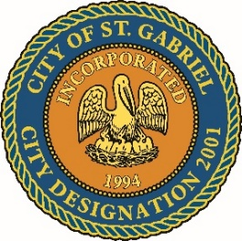

SPECIAL MEETING OF THE MAYOR AND CITY COUNCIL
THURSDAY, JUNE 8, 2023

ST. GABRIEL CITY HALL - 5035 IBERVILLE ST. – COUNCIL CHAMBERS

ST. GABRIEL, LOUISIANA

AGENDA

- CALL TO ORDER – ROLL CALL – PRAYER – PLEDGE OF ALLEGIANCE
- PUBLIC FORUM – Please register with the City Clerk prior to the beginning of the meeting indicating your topic of discussion. Topics should be on agenda items.
- NON-ACTION ITEMS
    - DISCUSSION - 2023-2024 Budget
- COUNCIL REPORT
- MAYOR REPORT
- ADJOURNMENT

