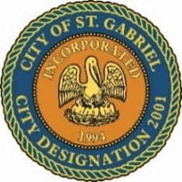

MAYOR & CITY COUNCIL MEETING AGENDA
St. Gabriel Council Chambers │5035 Iberville Street, St. Gabriel LA 70776
Thursday, January 18, 2024⎪6:00 p.m.
PUBLIC COMMENT POLICY
This is a public meeting. Items listed as "Introductions" will be available for public comment at subsequent meetings. Any member of the public who wishes to speak on an agenda item must sign in on the public comment sheet in Council Chambers. The mayor will call the name of each person who has requested to speak to the podium to comment for an amount of time designated by the Mayor not to exceed (3) minutes. Any interested person who does not wish to comment in person may submit a comment electronically at www.cityofstgabriel.us by clicking on City Hall then City Council. Electronically submitted comments will be acknowledged.

- CALL TO ORDER – ROLL CALL – PRAYER – PLEDGE OF ALLEGIANCE
- PUBLIC COMMENT
- ACTION ITEMS
  - MOTION CONSIDERATION - To Approve and Adopt Minutes for Regular Meeting dated December 21, 2023

- PRESENTATION
  - Koura
  - Louisiana Youth Challenge
- MAYORS REPORT
- ADJOURNMENT

