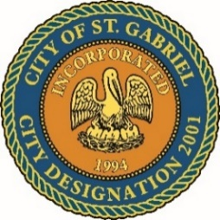

MAYOR & CITY COUNCIL MEETING
St. Gabriel Council Chambers
5035 Iberville St., St. Gabriel LA 70776

Thursday, November 16, 2023 AGENDA 6:00 p.m.

I. CALL TO ORDER – ROLL CALL – PRAYER – PLEDGE OF ALLEGIANCE

- PUBLIC FORUM – Please register with the City Clerk prior to the beginning of the meeting indicating your topic of discussion. Topics should be on agenda items.
- ACTION ITEMS

    - MOTION CONSIDERATION - To Approve and Adopt Minutes for Regular Meeting dated October 19, 2023

    - POLICE DEPARTMENT
      - MOTION TO BEGIN – A Public Hearing
St. Gabriel Police Department revised Manual of Regulations

      - MOTION TO END – A Public Hearing and Return to REGULAR Meeting
      - MOTION TO ADOPT - St. Gabriel Police Department revised Manual of Regulations
      - MOTION CONSIDERATION - Ratify employment of police personnel

Name Hire Date
Mike Hanks 8/21/2023
Alona Washington 11/2/2023
Sterling Redditt 11/3/2023

      - MOTION CONSIDERATION - To declare certain property of the City’s police department as no longer needed or useful for the uses and purposes of the City or its people, thus determining such property as surplus

    - MOTION CONSIDERATION – To discuss and approve amended Resolution #2017-0517-0002 in support of Taminco US, LLC

    - MOTION CONSIDERATION – Election for Mayor Pro Temp for 2023 Election Term

- MAYORS REPORT
- ADJOURNMENT

