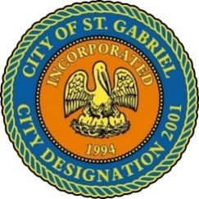

MAYOR & CITY COUNCIL MEETING AGENDA
St. Gabriel Council Chambers │5035 Iberville Street, St. Gabriel LA 70776
Thursday, April 18, 2024⎪6:00 p.m.
- CALL TO ORDER – ROLL CALL – PRAYER – PLEDGE OF ALLEGIANCE
- PUBLIC COMMENT
- MOTION CONSIDERATION - To Approve and Adopt Minutes for Regular
Meeting dated March 21, 2024
- MOTION TO BEGIN - A Public Hearing
  - An Ordinance adding and amending chapter 47 to the St. Gabriel, Louisiana code of ordinances, entitled: age restriction for mobile homes; manufactured homes; trailers; mobile home parks

  - An Ordinance an ordinance establishing that the city of St. Gabriel, Louisiana authorizes, sets, and assess costs, fees and fines associated with building permit fees for both residential construction and commercial construction for the city of St. Gabriel, Louisiana and other matters related thereto, pursuant to

- MOTION TO END – A Public Hearing and Return to Regular Meeting
- MOTION TO ADOPT
  - Agenda item 4. a.
  - Agenda item 4. b.

- POLICE DEPARTMENT
  - Personnel Matters: Employment Ratification
- MAYORS REPORT
- ADJOURNMENT

Public Comment Policy: This is a public meeting. Items listed as "Introductions" will be available for public comment at subsequent meetings. Members of the public who wish to speak on an agenda item must register on the public comment sheet. Persons who have properly registered will be called for comment for an amount of time designated by the Mayor not to exceed (3) minutes. Any interested person who does not wish to comment in person may submit a comment electronically at www.cityofstgabriel.us by clicking on City Hall then City Council. Electronically submitted comments will be acknowledged.

