**MAYOR & CITY COUNCIL MEETING AGENDA**

**St. Gabriel Council Chambers │5035 Iberville Street, St. Gabriel LA 70776**

**Thursday, November 21, 2024⎪6:00 p.m.**

1. **CALL TO ORDER – ROLL CALL – PRAYER – PLEDGE OF ALLEGIANCE**
2. **PUBLIC COMMENT**
3. **MOTION CONSIDERATION** - To Approve and Adopt Minutes for Regular Meeting dated October 17, 2024
4. 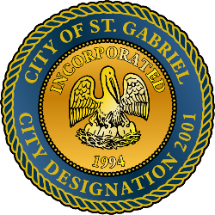**PUBLIC HEARING**
   1. **BEGIN Public Hearing** 
      1. To amend City of St. Gabriel Code of Ordinances Section 7.08 M2: Heavy Industrial District
      2. To amend City of St. Gabriel Code of Ordinances Chapter 66 Comprehensive Zoning Article I Section 1.19 Fees
   2. **END Public Hearing and Return to Regular Meeting**
   3. **APPROVE** 
      1. Amendment of City of St. Gabriel Code of Ordinances Section 7.08 M2: Heavy Industrial District
      2. Amendment of City of St. Gabriel Code of Ordinances Chapter 66 Comprehensive Zoning Article I Section 1.19 Fees
5. **ORDINANCE INTRODUCTIONS**
   1. To establish an ordinance setting wastewater fees for commercial use
   2. To amend City of St. Gabriel Code of Ordinances Section 2- 2: Municipal Vehicles
6. **MAYORS REPORT**
7. **ADJOURNMENT**