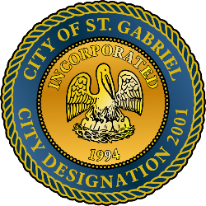

MAYOR & CITY COUNCIL MEETING AGENDA
St. Gabriel Council Chambers │5035 Iberville Street, St. Gabriel LA 70776
Thursday, December 19, 2024⎪6:00 p.m.
- CALL TO ORDER – ROLL CALL – PRAYER – PLEDGE OF ALLEGIANCE
- PUBLIC COMMENT
- MOTION CONSIDERATION - To Approve and Adopt Minutes for Regular Meeting dated November 21, 2024
- PUBLIC HEARING
  - BEGIN Public Hearing
    - To establish an ordinance setting wastewater fees for commercial use
  - END Public Hearing and RETURN to Regular Meeting
- MOTION CONSIDERATION – To approve an ordinance setting wastewater fees for commercial use
- EXECUTIVE SESSION/LEGAL MATTERS
- MAYORS REPORT
- ADJOURNMENT

Posted 12/18/2024 - 5:02 p.m.

