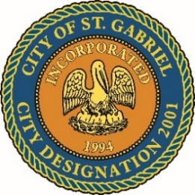

MAYOR & CITY COUNCIL MEETING AGENDA
St. Gabriel Council Chambers │5035 Iberville Street, St. Gabriel LA 70776
Thursday, June 19, 2025⎪6:00 p.m.
- CALL TO ORDER – ROLL CALL – PRAYER – PLEDGE OF ALLEGIANCE
- PUBLIC COMMENT
- MOTION CONSIDERATION - To Approve and Adopt Minutes for Regular Meeting dated May 20, 2025
- PRESENTATION – St. Gabriel Girl Scout Troop #10654
- PRESENTATION – The Middleburg Institute
- PRESENTATION - Application for rezoning from R1A to M1 – Light Industrial.
Presenter: Ty Gose on behalf of East West Land Co. LC
- MOTION TO APPROVE - 2025-2026 Holiday Schedule
- MOTION TO APPROVE – Resolution to Acquire Property for Drainage Improvements declaring the City of St. Gabriel’s intent to acquire property on St. Francis Lane for drainage improvements and authorizing the Mayor to negotiate and execute all necessary agreements for relocation and drainage design.
- MOTION TO APPROVE – Resolution to officially name St. Gabriel city park located on William Street, in honor of Leonard "Buck" Jackson, recognizing his contributions to the St. Gabriel community.
- MOTION TO BEGIN - A Public Hearing
  - Ordinance to amend COSG Code of Ordinances Section 2- 2: Municipal Vehicles
  - Proposed amendments of 2024-2025 Operating Budget and adopt 2025-2026 Financial Budget
- MOTION TO END – A Public Hearing and Return to Regular Meeting
- MOTION TO APPROVE
  - Ordinance to amend COSG Code of Ordinances Section 2- 2: Municipal Vehicles
  - Proposed amendments of 2024-2025 Operating Budget and adopt 2025-2026 Financial Budget
- POLICE DEPARTMENT
- MAYORS REPORT
- ADJOURNMENT

Amended 6/18/2025 5:50 p.m.

