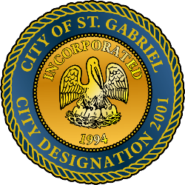

MAYOR & CITY COUNCIL MEETING AGENDA
St. Gabriel Council Chambers │5035 Iberville Street, St. Gabriel LA 70776
Thursday, December 18, 2025⎪6:00 p.m.
CALL TO ORDER – ROLL CALL – PRAYER – PLEDGE OF ALLEGIANCE
- PUBLIC COMMENT
- MOTION CONSIDERATION - To Approve and Adopt Minutes for Regular Meeting dated
November 18, 2025
- MOTION TO APPROVE – Resolution(s) of Condolence
- MOTION TO APPROVE – Resolution to accept negotiated purchase amount for parcels of land for retail purposes and authorize Mayor to negotiate and finalize all related matters thereof
- MOTION TO BEGIN - A Public Hearing,
  - Ordinance regarding Districts for City Council members – St. Gabriel Plan
  - Ordinance amendment to COSG Unified Development Code Section 10:16 – Home Occupations
- MOTION TO END – A Public Hearing and Return to Regular Meeting
- MOTION TO APPROVE
  - Ordinance regarding Districts for City Council members – St. Gabriel Plan (City of St. Gabriel Ordinance No. 2025-1118-0001
  - Ordinance amendment to COSG Unified Development Code Section 10:16 – Home Occupations
- FINANCE – Transfer of second payment for 2026 FY of approximately $800,000 to PD
- POLICE DEPARTMENT
- MAYORS REPORT
- ADJOURNMENT

