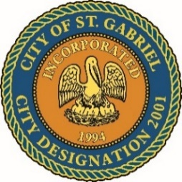

MAYOR & CITY COUNCIL MEETING AGENDA
St. Gabriel Council Chambers │5035 Iberville Street, St. Gabriel LA 70776
Thursday, August 21, 2025⎪6:00 p.m.
- CALL TO ORDER – ROLL CALL – PRAYER – PLEDGE OF ALLEGIANCE
- PUBLIC COMMENT
- MOTION CONSIDERATION - To Approve and Adopt Minutes for Regular Meeting dated July 17, 2025
- DISCUSSION – City of St. Gabriel Subdivision Regulations (Draft)
- CODE ENFORCEMENT
  - Update
  - Notification to correct or appear for dilapidated structures
- POLICE DEPARTMENT
  - Report/Recommendations
  - Executive Session (Personnel Matters)
- MOTION TO BEGIN - A Public Hearing
  - Ordinance to amend COSG Code of Ordinances Section 2- 2: Municipal Vehicles
  - Application for rezoning from R1A to C2 – Commercial.
Location: 3625 LA-75, St Gabriel, LA 70776
- MOTION TO END – A Public Hearing and Return to Regular Meeting
- MOTION TO APPROVE
  - Ordinance to amend COSG Code of Ordinances Section 2- 2: Municipal Vehicles
  - Application for rezoning from R1A to C2 – Commercial.
- MAYORS REPORT
  - Finance
  - Residential development
  - Economic development
- ADJOURNMENT

