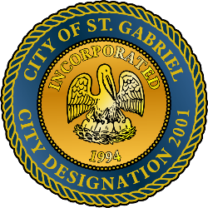

MAYOR & CITY COUNCIL MEETING AGENDA
St. Gabriel Council Chambers │5035 Iberville Street, St. Gabriel LA 70776
Thursday, April 16, 2026⎪6:00 p.m.
CALL TO ORDER – ROLL CALL – PRAYER – PLEDGE OF ALLEGIANCE
- PUBLIC COMMENT
- MOTION TO APPROVE - To Approve and Adopt Minutes for Regular Meeting dated
March 19, 2026
- MOTION TO APPROVE - Resolution of Condolence
  - Family of – Mr. James Stewart
  - Family of – Ms. Melissa Conrad
- RECOGNITION – East Iberville Boys Basketball Team – Division IV Non-Select State Runner-Up
- CODE ENFORCEMENT – Notification to correct or appear for dilapidated structures
  - 4565 Point Clair – dilapidated structure
  - 4965-A Maryland Street – dilapidated structure
  - 4885 Maryland Street - dilapidated structure
  - 4845 Landry Street - dilapidated structure
- MOTION TO BEGIN - A Public Hearing,
  - Ordinance to amend Section 10.16 - Home Occupations
- MOTION TO END – A Public Hearing and Return to Regular Meeting
- MOTION TO APPROVE
  - Ordinance to amend Section 10.16 - Home Occupations
- POLICE DEPARTMENT
- MAYORS REPORT
- ADJOURNMENT

