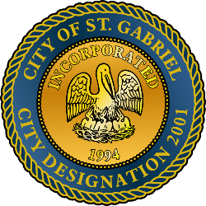

MAYOR & CITY COUNCIL MEETING AGENDA
St. Gabriel Council Chambers │5035 Iberville Street, St. Gabriel LA 70776
Thursday, May 21, 2026⎪6:00 p.m.

- CALL TO ORDER – ROLL CALL – PRAYER – PLEDGE OF ALLEGIANCE
- PUBLIC COMMENT - Please register with the City Clerk prior to the beginning of the meeting indicating your topic of discussion. Topics should be on agenda items.
- MOTION TO APPROVE - To Approve and Adopt Minutes for Regular Meeting dated
April 16, 2026 and Special Meeting dated May 13, 2026
- PRESENTATION – Orbia (Stakeholder Updates) by Erick Comeaux, Plant Manager
- PRESENTATION – Quality Engineering Presentation on potential City of St. Gabriel Sports Complex and ATV Park
- PRESENTATION – City Master Planning Presentation, Bret Keast, AICP, CEO and Owner of Kendig Keast Collaborative
- INTRODUCTION – Proposed 2026 – 2027 fiscal year budget and ordinance by Mayor Johnson and Faulk and Winkler, LLC
- POLICE DEPARTMENT
  - Personnel Matters: Employment Ratification

Employee: Hire Date:
Braylon Jones 3/20/26
Porcha Wilson 3/36/26
  - Employment Application – Patrick Lawayne Stevenson, Jr.
- MAYORS REPORT
- ADJOURNMENT

