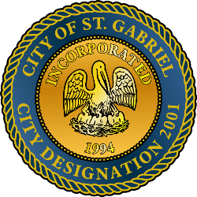

MAYOR & CITY COUNCIL MEETING AGENDA
St. Gabriel Council Chambers │5035 Iberville Street, St. Gabriel LA 70776
Thursday, June 18, 2026⎪6:00 p.m.
- CALL TO ORDER – ROLL CALL – PRAYER – PLEDGE OF ALLEGIANCE
- PUBLIC COMMENT - Please register with the City Clerk prior to the beginning of the meeting indicating your topic of discussion. Topics should be on agenda items.
- MOTION TO APPROVE - To Approve and Adopt Minutes for Regular Meeting dated
May 21, 2026 and Special Meeting dated June 3, 2026
- MOTION TO APPROVE – 2026-2027 Holiday Schedule
- MOTION TO APPROVE – A Resolution to Adopt the adjusted millage rate (s) for the 2026 tax season
- MOTION TO BEGIN - A Public Hearing
  - Proposed amendments of 2025-2026 Operating Budget and adopt 2026-2027 Financial Budget
- MOTION TO END – A Public Hearing and Return to Regular Meeting
- MOTION TO APPROVE
  - Proposed amendments of 2025-2026 Operating Budget and adopt 2026-2027 Financial Budget
- POLICE DEPARTMENT
  - Employment Application – Kyler Pierre
  - Employment Application – Dakota Fagan
- MAYORS REPORT
- ADJOURNMENT

