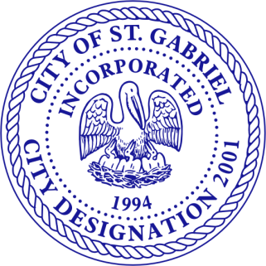
LIONEL JOHNSON, JR.
MAYOR

CITY COUNCIL
WILLIAM CUSHENBERRY, JR.
MELVIN HASTEN, SR.
JEFFERY HAYES, SR.
HOZA REDDITT, SR.
KELVIN YORK, SR.

KEVIN AMBEAU, SR.
POLICE CHIEF

CITY OF ST. GABRIEL

Commercial PRIORITY OF INSPECTIONS

PLEASE ABIDE BY THE BELOW PRIORITY LIST PRIOR TO CALLING FOR INSPECTIONS

Priority 1 Inspections

Temporary Pole
Pre-Pour Plumbing

Priority 2 Inspections

Electrical Underground Inspection
Foundation Inspection

Priority 3 Inspections

Sheathing Inspection
Above Ceiling- Mechanical Inspection
Framing Rough-In Inspection
Mechanical Rough-In Inspection
Electrical Rough-In Inspection
Plumbing Rough-In Inspection
Gas Test
Water Pressure Test

Priority 4 Inspections

Sheetrock/Firewall Inspection
Temporary Cut-In

Priority 5 Inspections

CO Inspection
Building Final Inspection
Mechanical Final Inspection
Electrical Final Inspection
Plumbing Final Inspection

